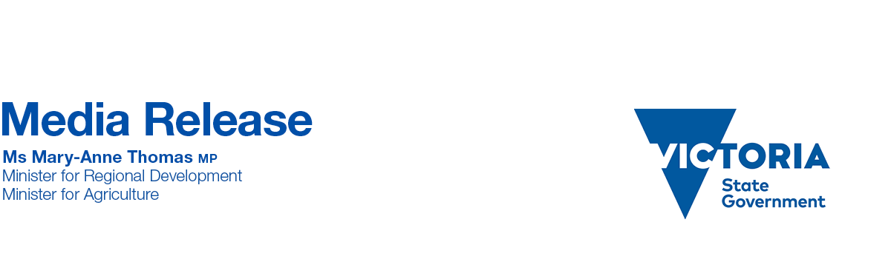Saturday, 15 May 2021

**TOURISM BOOST FOR HISTORIC BELLARINE RAILWAY**

Bellarine Peninsula’s historic railway will be given a facelift to encourage more visitors to the region, with new investment from the Andrews Labor Government.

Minister for Regional Development Mary-Anne Thomas today visited Drysdale Railway Station to inspect the early works taking place to revitalise this nationally-significant destination, which has received more than $3.4 million funding through the *Regional Tourism Investment Fund – Stimulus Round*.

The new investment will support stage two of the project, following the Labor Government’s previous investment of $300,000 for the first stage.

Stage one will include development of the Turntable Paddock at Drysdale Railway Station and improvements to community access, and will provide a base for the award-winning dining experience The Q Train, which travels along the historic Bellarine Railway.

Stage two will include an **upgrade of 16.5 kilometres of track between Drysdale and Queenscliff.** This project aims to establish Drysdale station as a gateway for the Bellarine Railway in Geelong and transform it into a tourist destination for locals and visitors to enjoy.

Other unique visitor attractions will benefit from upgrades to the heritage line including The Blues Train, Day Out with Thomas, train driver experiences and group charters, as well as family and special events.

The works will ensure the longevity of the railway line, improve the visitor offering, support tourism and boost jobs in the Bellarine Peninsula.

The $46 million ***Regional Tourism Investment Fund - Stimulus Round* forms part of the *Visitor*** *Economy Recovery and Reform Plan*, which is underpinned by an investment of $633 million.

For more information on the ***Regional Tourism Investment Fund - Stimulus Round* and the Visitor** *Economy Recovery and Reform Plan* visit[djpr.vic.gov.au](https://djpr.vic.gov.au/significant-projects/visitor-economy-recovery-and-reform-plan?utm_source=djpr-vic-gov-au&utm_medium=vanity-url-301ssredirect&utm_content=visitor-economy-recovery-and-reform-plan&utm_campaign=significant-projects).

**Quote attributable to Minister for Regional Development Mary-Anne Thomas**

*“This investment will benefit the Bellarine Peninsula’s visitor economy and create new jobs by taking advantage of the natural coastline, world class wineries and tourist railway.”*

**Quote attributable to Minister for Tourism, Sport and Major Events Martin Pakula**

*“We’re investing in experiences that enable more people to enjoy the natural beauty of our state and create Victorian jobs.”*

**Quote attributable to Acting Member for Bellarine Gayle Tierney**

*“This work is not only about breathing new life into the Bellarine Railway, but ensuring the future of the line. We know it will continue to be a popular drawcard, creating local jobs and bringing the community together.”*